Relevance
Sunflower in-depth programming was conducted by the Texas AgriLife Extension Service. The purpose of in-depth educational effort was to help producers be profitable in a very challenging market climate. Since crop production is a very involved and management intensive in an always changing environment the more informed producers are the better prepared they are to make sound management decisions that impact profitability. These decisions start many times a year in advance selecting weed control options, markets, crop rotations, soil fertility and others before the seed is ever planted. Dallam & Hartley Agriculture Program Area Committee has recognized that producers are being challenged and non-traditional crops like sunflowers can offer options in crop diversification that can be beneficial and enhance profitability. The producers in this area are very innovated and are experienced in growing crops in a very challenging environment.

Response
Sunflower in-depth programming featured a combination of educational, programs, result demonstrations, news media presentations, turn row meetings and field days.

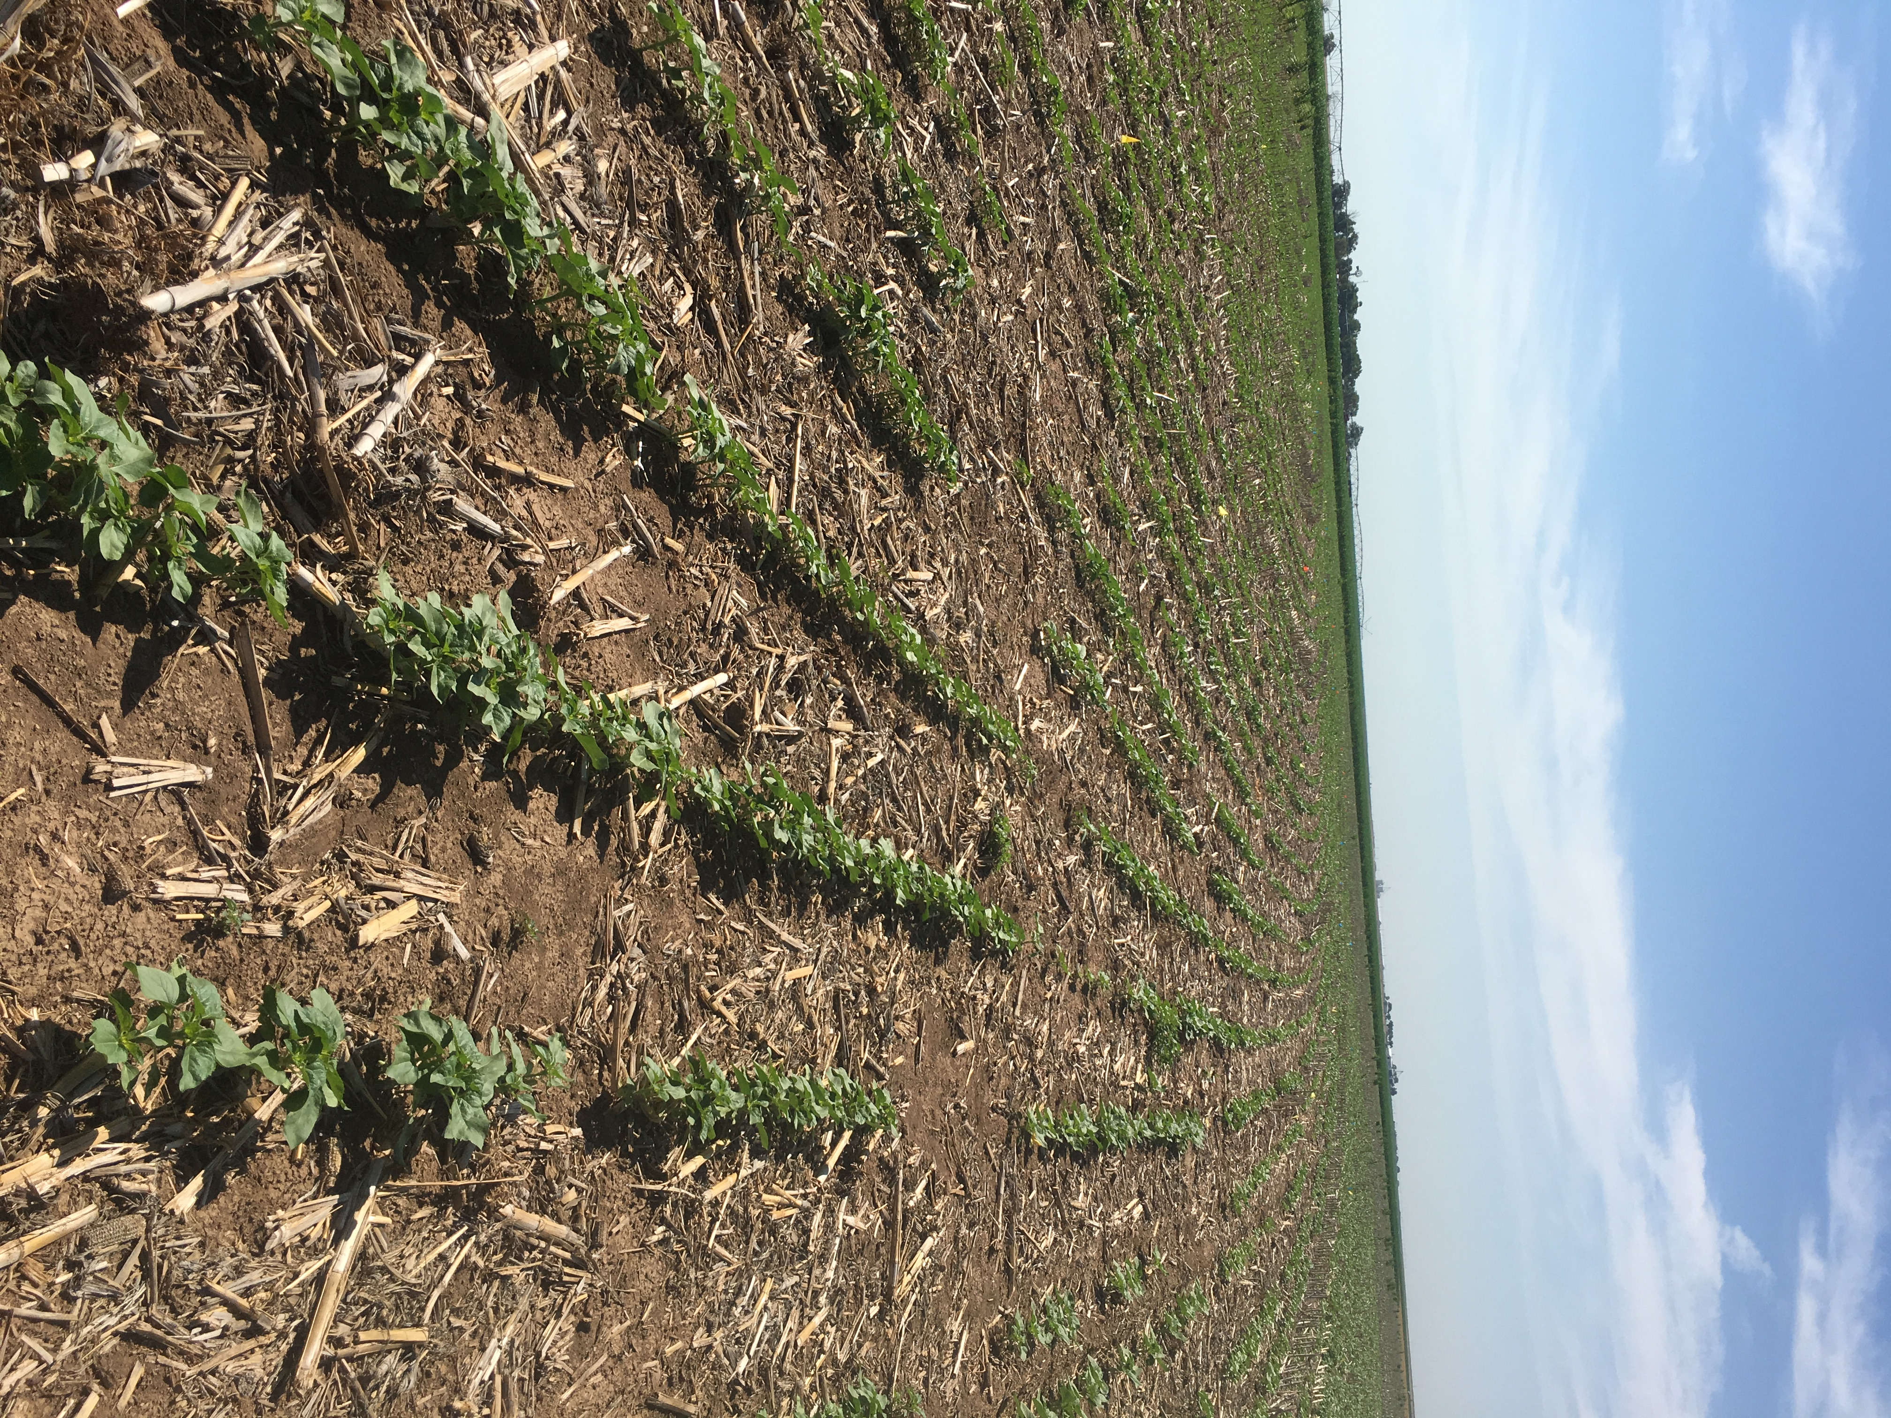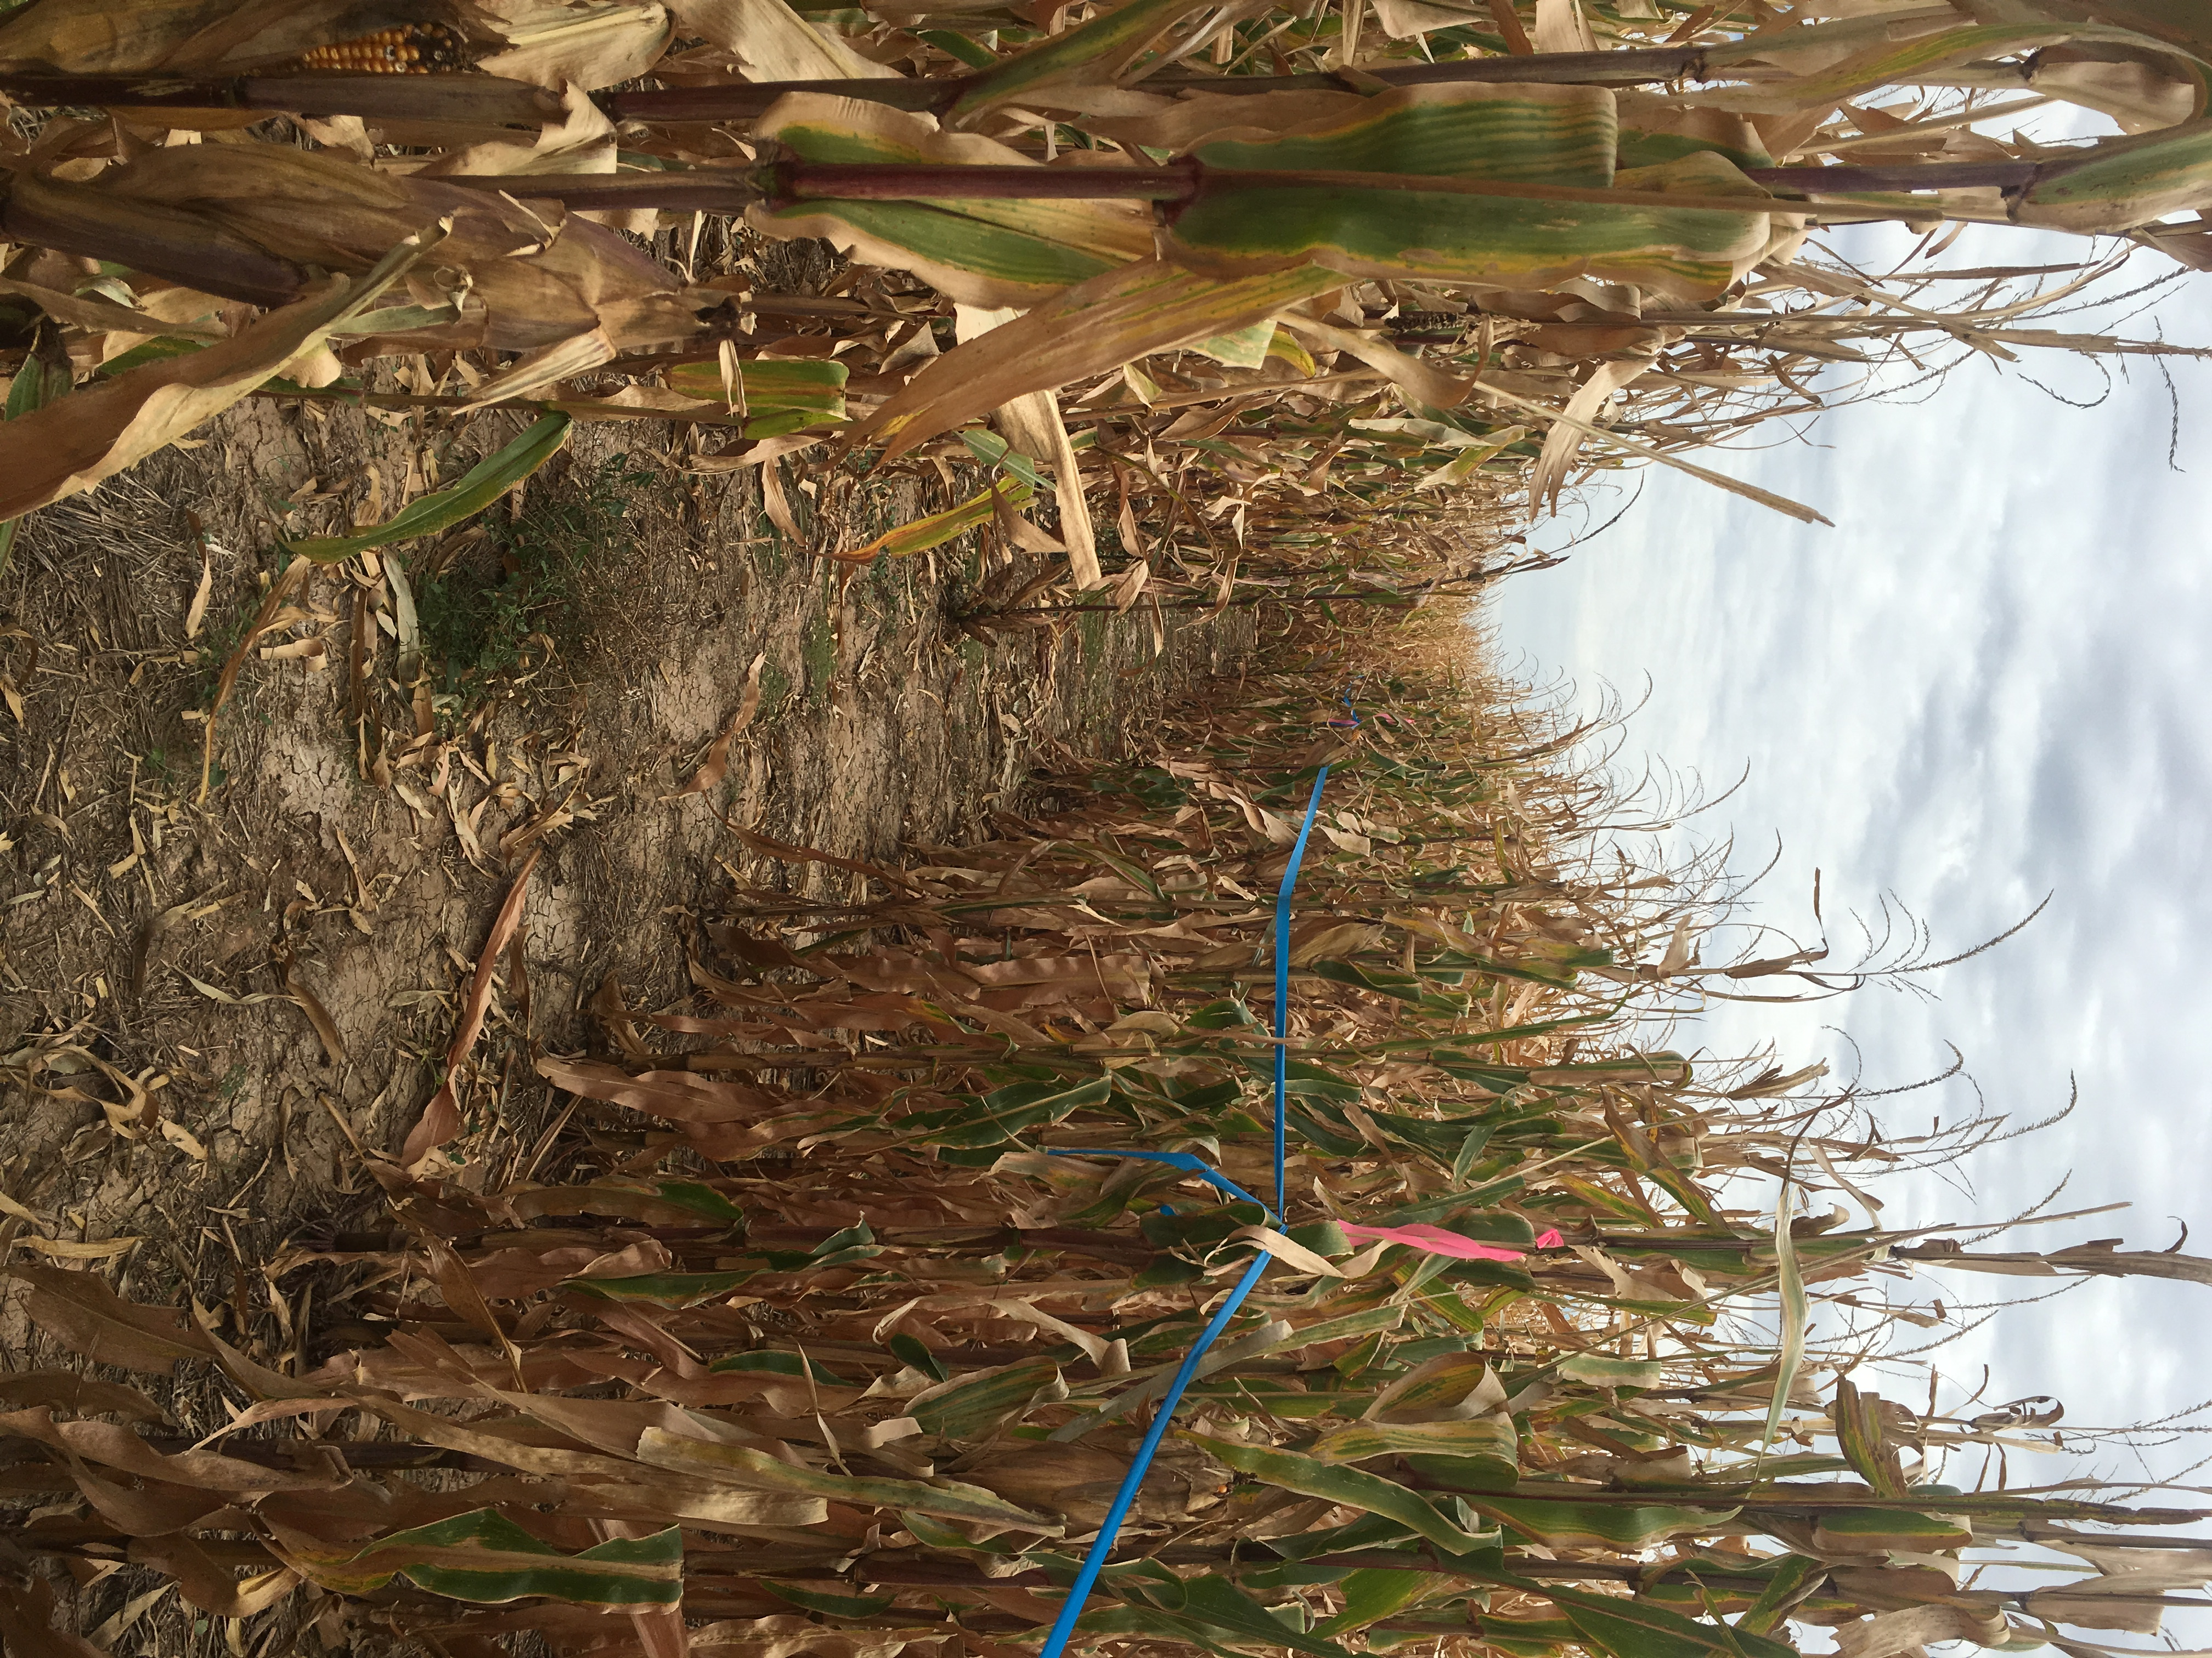
Multi-County Sunflower Production meeting held in Texline in January was attended by 40 producers. Result Demonstration work in Sunflower Variety Test plots featuring both oil seed and confectionary sunflowers was conducted on the Meyers farm in Dallam County. News Media presentations sunflower head moth management was presented by agent. Turn row meetings both at the field assisted producers with emerging needs with integrated pest management and irrigation. These turn row meetings focused on how to scout and manage pest. Field Day highlighted variety test plots and individual variety characteristics, harvest tips to enhance quality and production. Traditionally a small number of acres of predominately oil seed sunflowers were grown in Dallam & Hartley Counties. Although the sunflower production acres haven’t increased significantly compared to major crops grown in the area. Through AgriLife Extension education program efforts in Sunflowers the past several years we have seen an increase in confectionary sunflower production allowing producers to take advantage of new markets.

Above sunflower variety test plot on Meyers
Farm in Dallam County

Since the sunflower growing season is relative short compared to other summer crops grown in the area such as cotton, corn and grain sorghum. Sunflowers can offer producers a replant option behind a failed crop due to weather related damage. For example hailed out cotton many times there is no replant option for cotton due to the small planting window to acquire enough heat units for cotton and producers could replant those acres back to sunflowers. Another advantage for sunflowers is the lower irrigation water requirement and this can fit in situations where gallons per acre is too limited to produce corn.

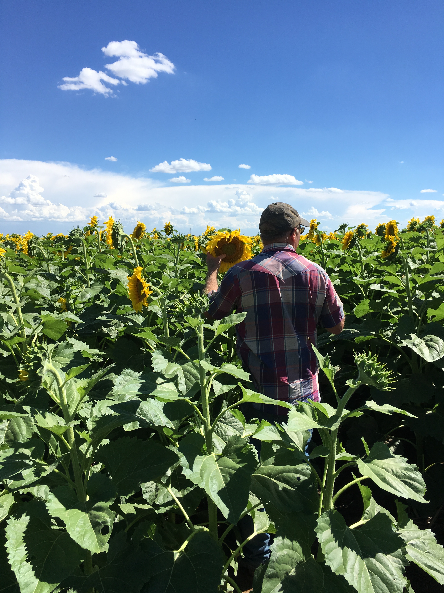
Sunflower field near Texline in Dallam County
Utilizing sound sunflower management concepts we can monitor the crops condition and enhance production. The cropping ecosystem is complex so years of site history provides a producer a better understanding of production capabilities and best management practices to apply. We know that a healthy and productive cropland has more value economically. Our challenge in this semi-arid region is to manage these croplands and their state of health and production through these cycles unpredictable weather.

Results
Objectives of the sunflower outcome was to
• Increase producer awareness of sunflower opportunities.
• Educate producers on management practices to enhance of sunflower production.

30 producers were surveyed at the Sunflower Field Day in Dalhart. These producers represented a total of over 4,000 acres of Sunflowers in the area. The top three highest percentages in increasing knowledge before and after the training was;
- 70% - pest control management and field scouting methods
- 35% - harvest tips to enhance quality and production
- 20 % - irrigation management

Producers intending on adoption of at least one practice or technology were 100% in these categories resulting in an economic benefit with an average economic of an additional $7.50 per acre.

